RESP derived atomic charges and atom types for [3.2.0]bcANA thymine monomer

atom | atom type
H2' | H1
O2' | OS
C6' | CT
H6' | H1
H6'' | H1

atom | charge |  | atom | charge |  | atom | charge
O5' | 0.5104 |  | H4' | 0.0451 |  | C6 | 0.3350
C5' | 0.0383 |  | O2' | 0.4358 |  | O2 | 0.5910
H5' | 0.0640 |  | C6' | 0.1104 |  | H3 | 0.3572
H5'' | 0.0640 |  | H6' | 0.0596 |  | O4 | 0.5661
C1' | 0.1246 |  | H6'' | 0.0596 |  | H6 | 0.3019
C2' | 0.1296 |  | O3' | 0.5817 |  | C7 | 0.2374
C3' | 0.2678 |  | N1 | 0.0386 |  | H71 | 0.0814
C4' | 0.2736 |  | C2 | 0.6032 |  | H72 | 0.0814
O4' | 0.4020 |  | N3 | 0.5065 |  | H73 | 0.0814
H1' | 0.0931 |  | C4 | 0.5903 |  | P | 1.1939
H2' | 0.0674 |  | C5 | 0.0061 |  | O1P | 0.7832
 |  |  |  |  |  | O2P | 0.7832

Table S2. Chemical shifts (in ppm) for d(CTGAT*ATGC):d(GCATATCAG). Values are given at 25 C relative to DSS.ª

 | H6/H8 | H5/H2/  CH₃ | H1' | H2' | H2'' | H3' | H4' | H5' | H5'' | H4/H6 | H4/H6 | H1/H3
C1 | 7.81 | 5.96 | 5.95 | 2.08 | 2.55 | 4.69 | 4.11 | 3.79 | 3.79 | – | –
T2 | 7.45 | 1.67 | 5.65 | 2.14 | 2.44 | 4.87 | 4.15 | 3.97 | 4.04 |  |  | –
G3 | 7.93 |  | 5.64 | 2.74 | 2.85 | 5.04 | 4.38 | 4.10 | 4.05 |  |  | 12.59
A4 | 8.32 | 7.76 | 6.43 | 2.74 | 3.25 | 5.12 | 4.54 | 4.54 | 4.26 | – | –
T*5 | 7.06 | 1.51 | 5.43 | 5.45 |  |  | 4.11 | 3.92 | 4.08 |  |  | 13.46
A6 | 8.05 | 7.11 | 6.19 | 2.59 | 2.90 | 4.96 | 4.41 | 4.11 | 4.28 | – | –
T7 | 7.08 | 1.31 | 5.76 | 1.98 | 2.38 | 4.87 | 4.17 | 4.14 | 4.28 |  |  | 13.54
G8 | 7.85 |  | 5.92 | 2.59 | 2.70 | 4.97 | 4.35 | 4.07 ^{b} | 4.11 |  |  | 12.73
C9 | 7.49 | 5.47 | 6.21 | 2.18 | 2.18 | 4.49 | 4.07 | 4.24 ^{b} | 4.07 | 6.66 | 8.13
G10 | 7.95 |  | 5.99 | 2.62 | 2.80 | 4.85 | 4.22 | 3.71 | 3.71 |  |  | –
C11 | 7.47 | 5.44 | 5.70 | 2.19 | 2.50 | 4.89 | 4.23 | 4.09 ^{b} | 4.15 | 6.53 | 8.40
A12 | 8.36 | 7.66 | 6.31 | 2.74 | 3.00 | 5.04 | 4.46 | 4.14 | 4.20 | – | –
T13 | 7.22 | 1.53 | 5.82 | 2.24 | 2.64 | 4.91 | 4.25 | 4.25 | 4.31 |  |  | 13.07
A14 | 8.13 | 7.03 | 6.17 | 2.51 | 2.85 | 4.92 | 4.38 | 4.06 ^{b} | 4.23 | – | –
T15 | 7.22 | 1.15 | 5.99 | 2.01 | 2.41 | 4.85 | 4.21 | 4.08 ^{b} | 4.03 |  |  | 13.55
C16 | 7.50 | 5.64 | 5.40 | 2.00 | 2.28 | 4.82 | 4.06 | 4.20 | 4.06 ^{b} | 6.74 | 8.50
A17 | 8.19 | 7.76 | 6.02 | 2.70 | 2.84 | 5.02 | 4.38 | – | 4.01 | – | –
G18 | 7.74 |  | 6.03 | 2.46 | 2.28 | 4.63 | 4.18 | 4.08 ^{b} | 4.11 |  |  | –

ª The protons in the C2',C3' oxy-methylene bridge have the following chemical shift values: T*5 H6' 5.31 ppm and H6'' 5.35 ppm. ^{b} Tentative assignment.
Table S3. A selection of helix parameters for d(CTGAT*ATGC):d(GCATATCAG). Values for standard A- and B-type duplexes are included for comparison

 | X-disp  (Å) | Y-disp  (Å) | Tip  () | Inclin  () | Prop.Twist  () |  | Twist  () | Roll  () | Rise  (Å)
C1 | 3.0 | 0.14 | 6.9 | 0.7 | 5.3 | C1–T2 | 24.9 | 3.6 | 2.8
T2 | 3.0 | 0.12 | 5.7 | 4.8 | 11.5 | T2–G3 | 31.5 | 11.4 | 3.3
G3 | 2.9 | 0.22 | 9.2 | 1.8 | 8.0 | G3–A4 | 37.9 | 1.9 | 3.2
A4 | 2.9 | 0.17 | 6.9 | 4.3 | 12.9 | A4–T*5 | 30.8 | 3.9 | 3.1
T*5 | 2.8 | 0.17 | 3.5 | 5.2 | 13.7 | T*5–A6 | 32.2 | 0.8 | 2.8
A6 | 2.6 | 0.15 | 2.8 | 5.2 | 11.3 | A6–T7 | 34.6 | 0.9 | 3.2
T7 | 2.8 | 0.27 | 1.6 | 4.7 | 21.9 | T7–G8 | 38.2 | 2.7 | 3.0
G8 | 2.4 | 0.25 | 0.5 | 6.5 | 8.8 | G8–C9 | 32.2 | 2.4 | 3.3
C9 | 2.5 | 0.15 | 0.1 | 6.2 | 2.2
A-type | 5.4 | 0.0 | 0.0 | 19.1 | 13.7 |  | 32.7 | 0.0 | 2.56
B-type | 0.7 | 0.0 | 0.0 | 5.9 | 3.7 |  | 36.0 | 0.0 | 3.38

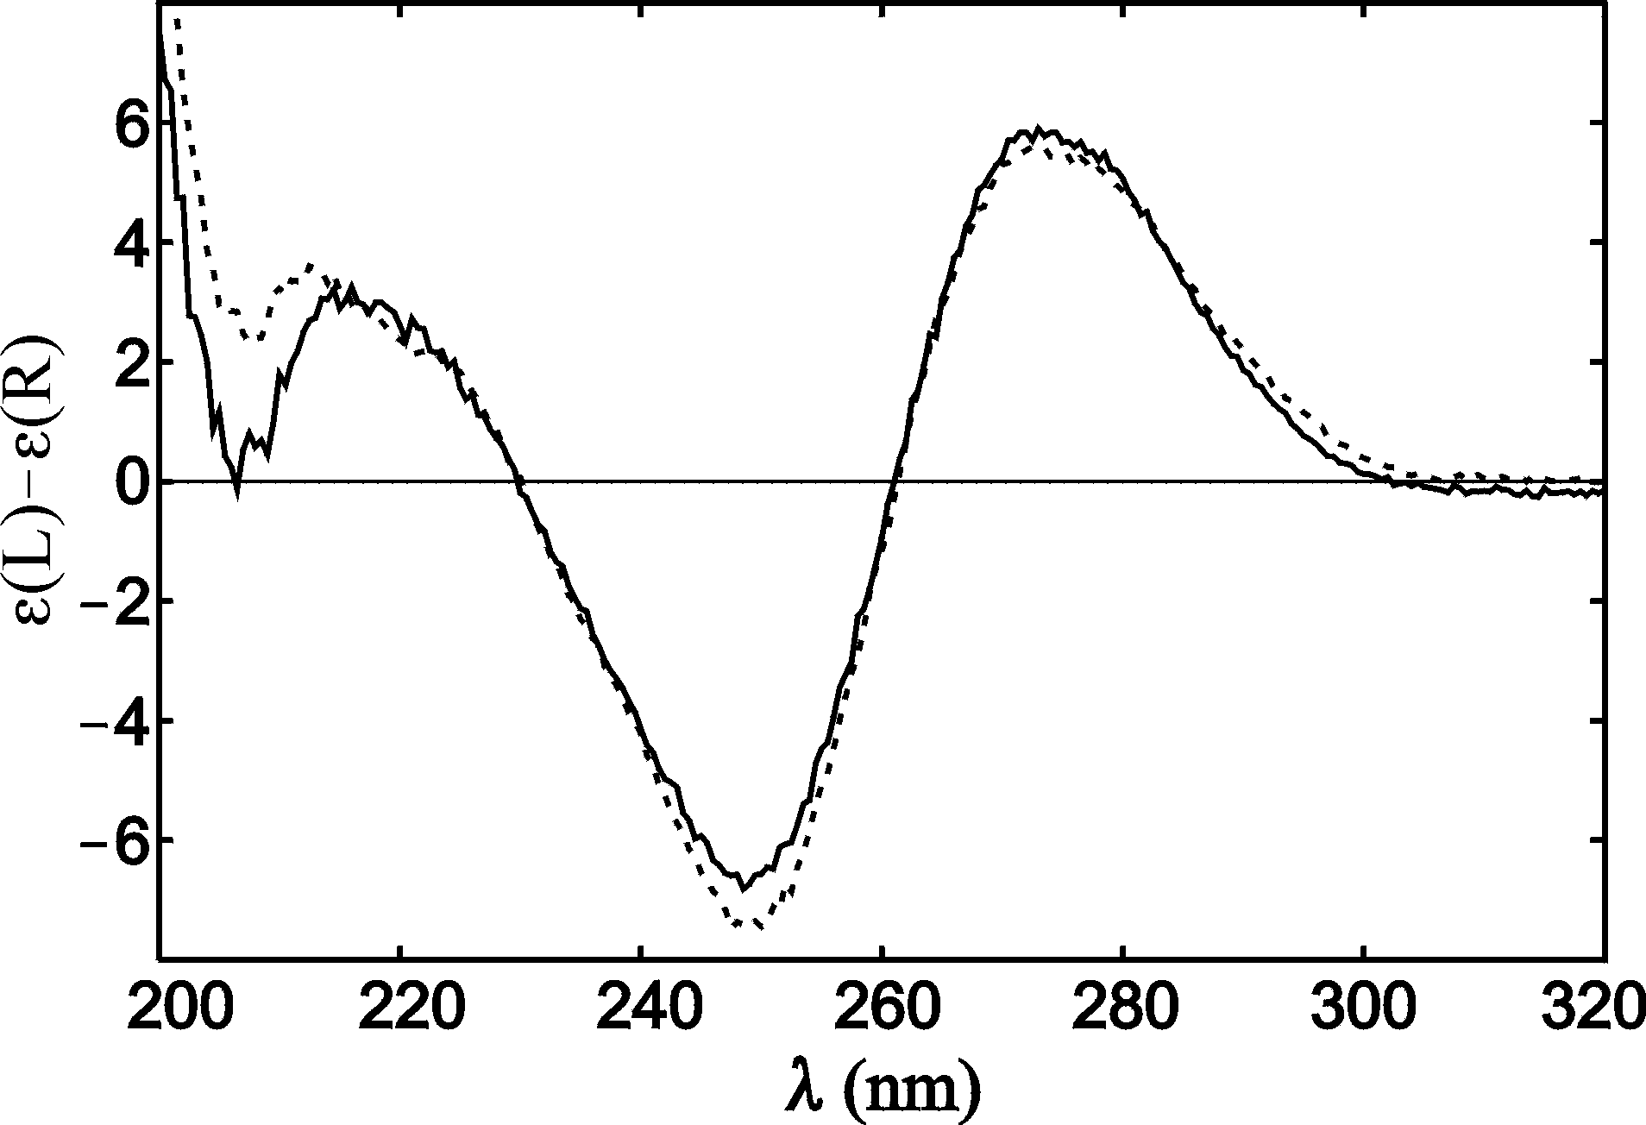

Figure S1. The CD spectrum of the [3.2.0]bcANA modified duplex (fully drawn line) and the corresponding unmodified dsDNA (broken line).

